This File shows the working of the program at every step.

1.Checking for java version:

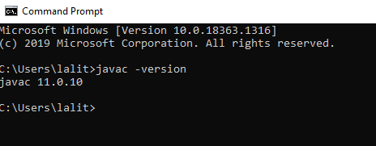

2. Compiling the program

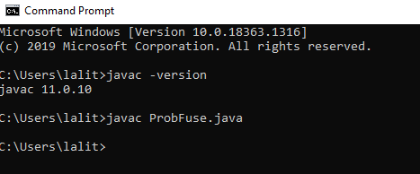

3. Running the Program

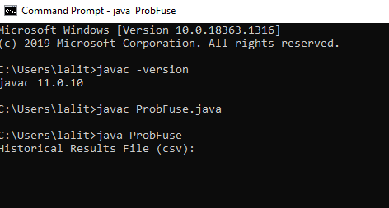

4. User Input For historical results file

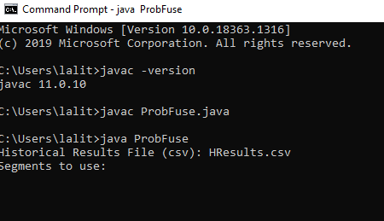

5. User input for choosing the number of segments

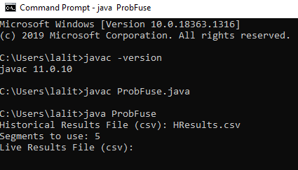

6. User input for Live results file:

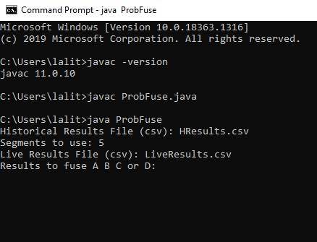

7. Choosing the IR engines to fuse and their result

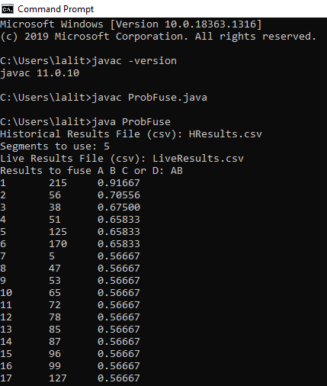

8. Program execution error when choosing the invalid IR engines (i.e., same engines) to fuse

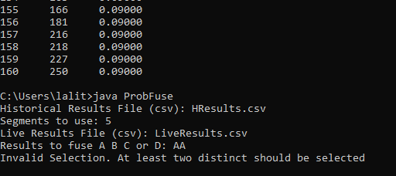

9. An output file will also be generated which the results of fusion, The results contain the rank, document id and its score

